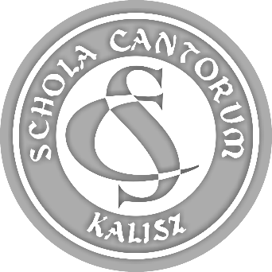 | PARTICIPATION FORM  44th SCHOLA CANTORUM  Tadeusz Krokos  International  Festival of Early Music Ensembles  Kalisz 2022

ATTACHMENT 6.

DECLARATION CONCERNING COVID-19
- in accordance with section 8.17 of the Regulations,
(every participant of the Festival completes the Declaration individually,
the signed document must be submitted on arrival or sent as a scan).

Name of ensemble:
First name and surname:

1. In connection with COVID-19 pandemic I hereby declare:
- I am not infected to the best of my knowledge,
- I am not under quarantine or epidemic surveillance,
- I have the COVID-19 Vaccination Passport (*),
- I do not have the COVID-19 Vaccination Passport (*).

Date: | …....... 2022
Signature of adult participant
or legal guardian of nonadult participant

Attention:
(*) - delete as appropriate.

