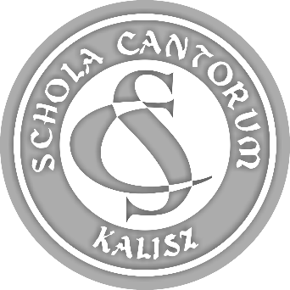 | PARTICIPATION FORM  44th SCHOLA CANTORUM  Tadeusz Krokos  International  Festival of Early Music Ensembles  Kalisz 2022

ATTACHMENT 5.

DECLARATION
OF CONFORMITY WITH ACT ON COPYRIGHT AND RELATED RIGHTS
(Journal of Laws 1994 No 24 item 83)
- referring to ensembles in category V, section 7.6.f, in accordance with section 8.6 of the Regulations,
as well as to ensembles whose programmes include compositions specified in section 7.6.e,
in accordance with section 8.6.
(it is obligatory to send the scanned and signed document).

Name of ensemble:

In accordance with section 7.6.f and section 8.6. of the Regulations of the 44th SCHOLA CANTORUM
- International Festival of Early Music Ensembles in Kalisz I hereby declare that the ensemble uses music on audio data carriers during the Festival and accompanying events:
- in compliance with act on copyrights and related rights (Journal of Laws 1994 No 24 item 83)
and resulting actions taken by copyright protection institutions (*),
- with the written consent of the author of the used music (*).

Date: | …....... 2022
Legible signature of legally responsible person:

Attention:

(*) - delete as appropriate.

