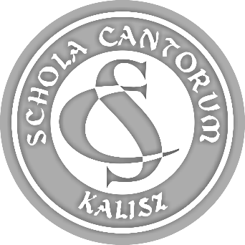 | PARTICIPATION FORM  44th SCHOLA CANTORUM  Tadeusz Krokos  International  Festival of Early Music Ensembles  Kalisz 2022

ATTACHMENT 4

(12.) SHORT DESCRIPTION OF THE ENSEMBLE
INFORMATION ABOUT PERFORMANCES, RECEIVED AWARDS AND MERITS
(the information will be published in Festival publications,
the Organiser reserves the right to correct or shorten the provided descriptions).

Name of ensemble:

Information about ensemble (write below):

