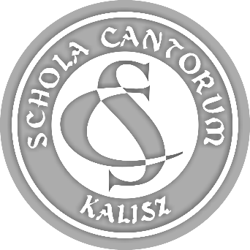 | PARTICIPATION FORM  44th SCHOLA CANTORUM  Tadeusz Krokos  International  Festival of Early Music Ensembles  Kalisz 2022

ATTACHMENT 2.

(10.) NAMES OF ENSEMBLE MEMBERS INCLUDING DATES OF BIRTH
- performers only.

Name of ensemble:

Line-up (write below, first name and surname, date of birth):

