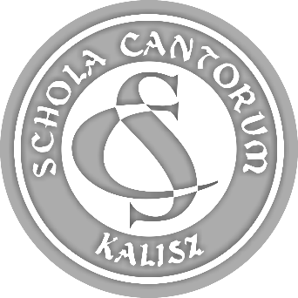 | PARTICIPATION FORM  44th SCHOLA CANTORUM  Tadeusz Krokos  International  Festival of Early Music Ensembles  Kalisz 2022

ATTACHMENT 1.

(9.) NUMBER OF THE ENSEMBLE MEMBERS
- including adults.

Name of ensemble:

LINE-UP | NUMBER OF WOMEN | NUMBER OF MEN | TOGETHER
members of ensemble (performers):
staff (conductor, manager, instructor, leader):
driver (and other accompanying persons):
TOGETHER:

